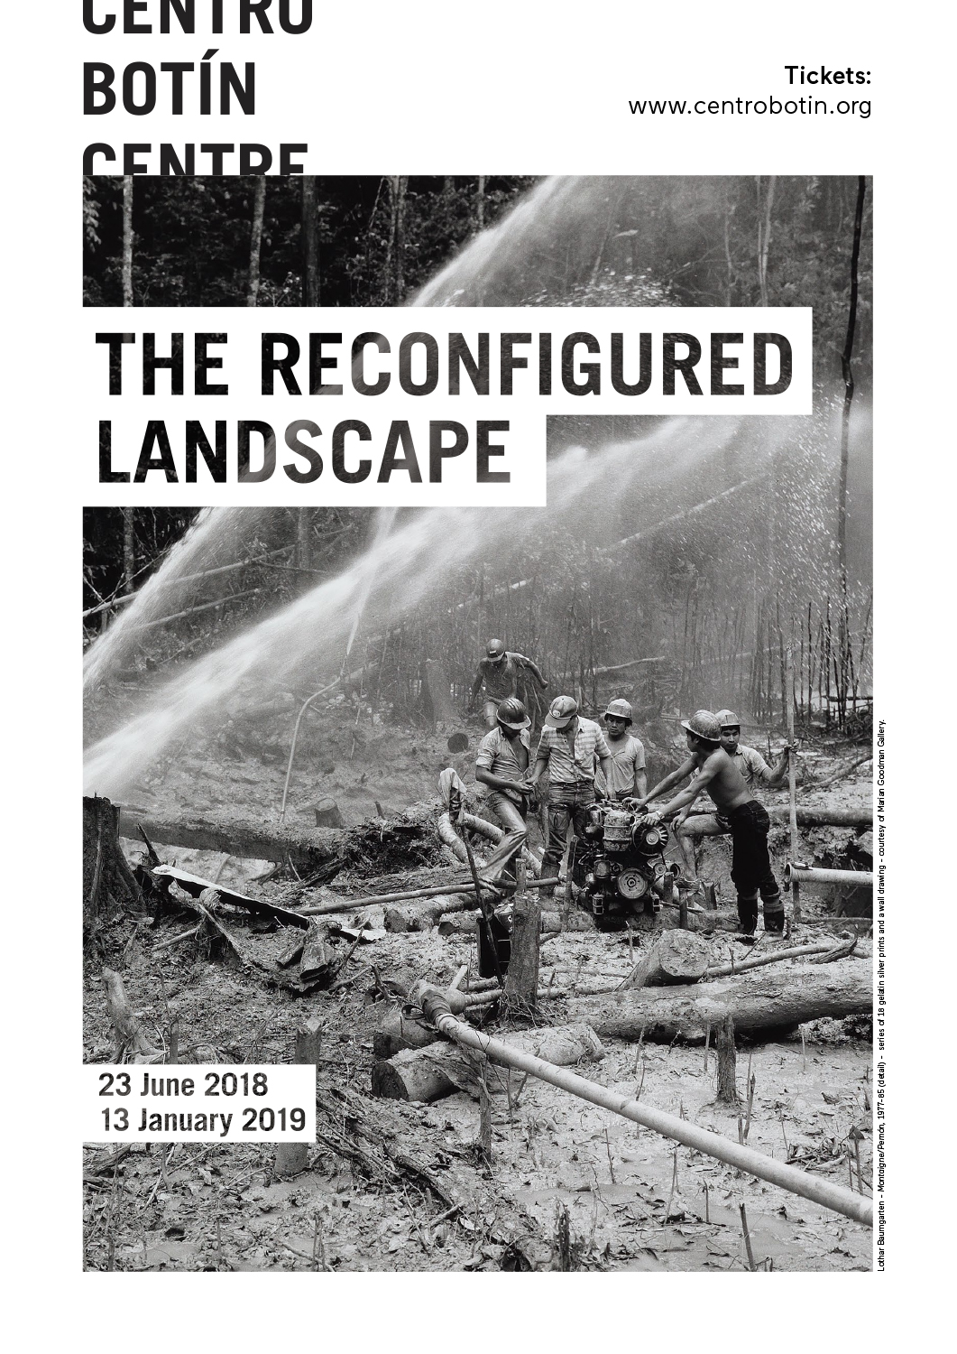
CENTRO BOTÍN PRESENTS THE RECONFIGURED LANDSCAPE, A JOURNEY THROUGH THE VISUAL ARTS IN THE LAST DECADE
- Leonor Antunes, Lothar Baumgarten, Joan Jonas and Irene Kopelman, among other artists, afford a fascinating overview of the various approaches taken by art practitioners to capture their surrounding landscape.
- The Reconfigured Landscape, featuring a selection of works from the Fundación Botín collection, runs from 23 June to 6 October 2018.
Santander, 22 May 2018.- This coming 23 June, Centro Botín is opening the exhibition The Reconfigured Landscape. The exhibition will remain on view until 6 October on the first floor of Centro Botín. It features a selection of works from the Fundación Botín collection by renowned Spanish and international contemporary artists: among them, Leonor Antunes, Lothar Baumgarten, Tacita Dean, Joan Jonas, Irene Kopelman, Julie Mehretu and Oriol Vilanova. It surveys different ways of representing our surrounding world, while also offering a historical overview of Fundación Botín’s ongoing engagement with the visual arts over the last ten years. Many of the works on view are exhibited here for the first time. Indeed, all the artists in the collection either directed a Fundación Botín’s Visual Arts workshops or once was a recipient of a Fundación Botín Visual Arts Grant. Many of these artists have gone on to become key figures in their generation, such as João Onofre, Sara Ramo or Ignacio Uriarte.
“This mix of generations is an important dynamic of the collection. It provides an interesting perspective on artistic practice in the twenty-first century, and mirrors the formal freedom artists have consolidated over the past fifty years”, explains Benjamin Weil, artistic director of Centro Botín and curator of the exhibition.
In addition to painting, drawing and sculpture, The Reconfigured Landscape includes videos and multimedia installations, a form that perhaps epitomizes the forefront of artistic research in the past few decades.
“We could look on this exhibition as a walkthrough of the artistic landscape of recent years in which artists have searched for different ways of representing their surrounding world”, says Weil.
On this journey through the visual arts of the last decade, Leonor Antunes (Lisbon, 1973) envisions sculpture in relation to the space it is presented in. Random intersection #14 is part of a series started in 2007, whose design refers directly to horse bridles, and is inspired by collages made by the Italian architect Carlo Molino as preparatory work for his plans for the Società Ippica Torinese (Turin Horse Club). These harness-like structures are connected to the space with an intricate network of hemp rope, creating a kind of ghostly presence in the space, in contrast with the density of the surrounding architecture.
Meanwhile, the work of Lothar Baumgarten (Rheinsberg, 1944), questions Western systems of thought and representation, as well as the ways its perception of and relation to other cultures are constructed. From 1977 to 1986, he travelled to primal forests in Central America, and lived with autochthonous tribes who had had little contact with the outside world. His photographs reflect upon how Western fantasies of paradise and indigenous people’s lives contrast heavily with living conditions systematically degraded by international conglomerates. The wall painting lists the names of indigenous tribes, and the territories they still occupy.
- Collecting objects and architectural fragments is core to the work of Jacobo Castellano (Jaen, 1976). He accumulates them until they find their way into his elaborate sculptural compositions. As a result, the sculptures, made of fragments of wood furniture or architectural elements, and completed with objects and artefacts, become like snapshots of mingled past histories.
Tacita Dean (Canterbury, 1965) makes films using celluloid, whose physical handling relates to drawing and sculpture, other mediums she uses in her work. Her 35mm film is titled after the initials of British author J.G. Ballard (1930-2009), with whom Dean enjoyed a long-running correspondence based on their mutual interest in Robert Smithson’s iconic earthwork and related film, Spiral Jetty (both works, 1970). The connections between Ballard’s fiction and Smithson’s earthwork are unequivocal. JG is a meditation on time—human, prehistoric and cosmic—that also ponders the notion of landscape, and more specifically the loss of scale and a certain sense of timelessness one can experience in a desert.
Fernanda Fragateiro (Portugal, 1962) has unfolded a body of work that reflects upon the impact of architecture on human interaction, but also its sculptural quality. Most of her works take their formal cue from architectural details or fragments, while she often uses found construction material she gathers while roaming around the city. Um caminho que não é um camino is a replica of a duckboard pathway she encountered while scouting the grounds of Ciudad Abierta (Open City), A unique open-air laboratory for architecture and urban planning conceived in the early 1970s by an architect and a poet, located outside of Valparaiso, in Chile. It TAkes its title from the 1996 publication Road that Is Not a Road and the Open City, Ritoque, Chile.
One can see another way of redefining space in the work Don Quijote también esculpió el aire, by Nuria Fuster (Alicante, 1978). The artist often uses refuse and leftovers from a consumer society for which an object becomes obsolete before it ceases to be operative. In this work, an effigy of Don Quixote serves as the key protagonist, imbuing it with a theatrical plot. Fuster builds the set out of a sheet of iron that serves as a screen, and a vacuum cleaner she uses to blow air onto the blades of an otherwise idle industrial fan, which evokes the windmills of the famous Cervantes epic.
- The complex relationship between human beings and nature and the environment is the predominant issue in the work of Joan Jonas (New York, 1936). Over the course of the past fifty years, Joan Jonas has pioneered a formal language that mixes performance, drawing, as well as video. In this work, Jonas used wall painting for the first time, in order to create an immersive environment that evokes both cave paintings and a forest inhabited by birds. In it, she staged a two-channel video work that blends references to her extensive travel around the world as well as to her exploration of the rural landscapes of Cantabria. The footage consists of an intricate and layered montage that uses landscapes as backgrounds for her performance and the ones by young artists who collaborated with her.
- Since her beginnings, drawing has been central to Joan Jonas’s practice, understanding it both as an action itself and the traces left by the action. During her performances, the artist draws directly on a surface—paper, slate, wall, easel, screen or floor—while at times, she also projects the drawing she makes in real time on a screen using an overhead projector or video camera, and she also sometimes incorporates previously recorded material.
- Joan Jonas spent a large part of her childhood in the countryside, in some ways explaining her strong connection with nature and, as a result, her concern with our relationship with our environment.
In her work, Irene Kolpelman (Argentina, 1974) documents her keen observation of the environment with large series of drawings, in an attempt to decipher the way knowledge is produced and shared. In doing so, she also reflects upon the way scientists and naturalists have eschewed the empirical for a more rational and structured manner of understanding nature, and elaborated all kinds of systems of classification, something that may explain how art and science have parted ways when they once seemed to be much closer. Indexing Water was produced in collaboration with with Marcel Wernand, a doctor in Physical Oceanography at NIOZ (Royal Netherlands Institute for Sea Research).
Produced in collaboration with an oceanographer, this new set of works displays various systems of recording the colour and degree of transparency of bodies of water around the world since the nineteenth century. Each component of her installation refers to specific nomenclature and scales used to describe water. Together, all these elements create a complex system of representation, which also calls for a reflection on how this shapes perception and understanding.
Sol Lewitt (Hartford, CT, 1928 - New York, NY, 2007) was a key proponent of a new way of envisaging the work of art. Dissociating the idea from the process of production, he conceived his Wall Drawings as a set of instructions anyone could execute. Those works therefore exist in a dematerialized form until someone produces them directly on the wall of the exhibition space, scaling them according to the dimensions of each venue. Wall Drawings are erased so they can be executed again on a new wall: they are always subject to new interpretations, not unlike musical scores. The colour scheme is based on four colours: yellow, red, blue and black; while all the geometric forms are derived from a single line inclined in a different direction – vertical, horizontal, or oblique. LeWitt started producing Wall Drawings in 1968 and continued producing new ones until his death. Wall Drawing #499, Flat-topped pyramid with color ink washes superimposed was first produced in 1986 in New York.
- Julie Mehretu (Addis Abeba, 1970), who has had a recent solo show at Centro Botín, is represented in the collection with Epigraph, Damascus, 2016 - a six-panels large-scale print - and Conjured Parts (Sekhmet), a 2016 painting. Her multi-layered compositions express the complexity of a globalized realm in which the advent of high-speed networked communication has profoundly transformed our perception of space and time. They depict a world in a state of chaos, and denote the artist’s persistent engagement with social and political urgencies. Both the painting and prints are part of a recent body of work, which relates to the civil war in Syria.
João Onofre (Lisbon, 1976) has been unfolding a body of work using primarily drawing, sound, and video. His films mostly document staged actions that border on the absurd, with a deliberate existential underpinning. As such, they offer a humorous yet serious look at the human condition. In this instance, Onofre placed a rare tropical palm tree onto a raft that resembles a tropical desert island. He then filmed it drifting down the Tagus River. An evanescent or ghostly presence passing by the city of Lisbon and under its two emblematic bridges, it appears from upstream, to disappear eventually into the horizon as it reaches the delta of the river at sunset. This incongruous vessel could evoke the ghostly presence of a migrating body that continuously flees, or perhaps an unattainable paradise island.
- Core to Sara Ramo’s (Madrid, 1975) artistic research, is her interest in how conventions and rituals vary from one culture to another and how this affects perception and understanding. Having split her life between Spain and Brazil, from very early on, Ramo experienced these differences personally. Brazil also happens to be a place where many different cultural influences have blended into each other. Os Adjudantes (The helpers) is the second in a trilogy of short films that focuses on music performances. Indeed, rituals for experiencing music vary drastically from a concert hall to a ritual dance or other spiritual undertakings in primal cultures. Blending various cultural references, Ramo stages rituals of her own invention. She confronts the viewer with the way s/he creates meaning, consciously or not.

- Before dedicating his time to making art, Ignacio Uriarte (Krefeld, 1972) studied business and worked in corporations. There, he observed the rituals of office life and the way work is organized to exemplify rational efficiency. His work therefore focuses on repetitive tasks, resulting in a body of work carried out predominantly in series, using such emblematic materials as A4 copy paper; ballpoint pens; pencils; permanent markers. His representation of office work however points to the extraordinary shift that has occurred in the past few years, as computer screens and electronic communication have completely changed office rituals. Hence, one is inclined to think more of Uriarte’s work in relation to the aesthetics of Conceptual Art. This series of nine drawings is produced on A1 paper (8 A4 sheets); it consists of a series of grids that somehow reflect on the impossibility of the perfect reproduction of a task by a human being.
Finally, the exhibition The Reconfigured Landscape also includes the work of Oriol Vilanova (Manresa, 1980), which is rooted in collecting and classifying artefacts. His specific interest lies in postcards, which exacerbate the clichéd vision one may have of a place; in that sense, they are a testimony to how tourism tends to oversimplify the world to make it more decipherable, more consumable. What may appear neutral is in fact telling of how a culture chooses to represent itself. Exhibited as a whole, these collections become meta-images, with each unit acting as a kind of pixel or building block. Si la noche fuese un color is made up of 700 postcards of night-time landscapes.

Images for press use
- To download graphic material available for the exhibition with their corresponding credits, please register in the press section on the Centro Botín webpage.
- …………………………………………………………

Centro Botín, designed by the architect Renzo Piano, is a project by the Fundación Botín that aspires to become a benchmark private art centre in Spain and a stopover on the international circuit of world-class art centres, contributing from Santander, through arts, to the development of creativity as a means to generate economic and social wealth. It will also be a pioneering v in the world for the development of creativity, leveraging art’s potential for the development of people’s emotional intelligence and creative power. Finally, it will be a meeting place in a unique setting in the centre of Santander, adding to the cultural offer on Spain’s Northern coast and becoming a driving force for the national and international promotion of the city and the region of Cantabria.

For more information:
Fundación Botín
María Cagigas
mcagigas@fundacionbotin.org
Tel.: +34 942 226 072

