Press Release
24th January 2019

ALEXANDER CALDER, MARTIN CREED AND ANRI SALA ANNOUNCED FOR CENTRO BOTÍN EXHIBITION PROGRAMME 2019

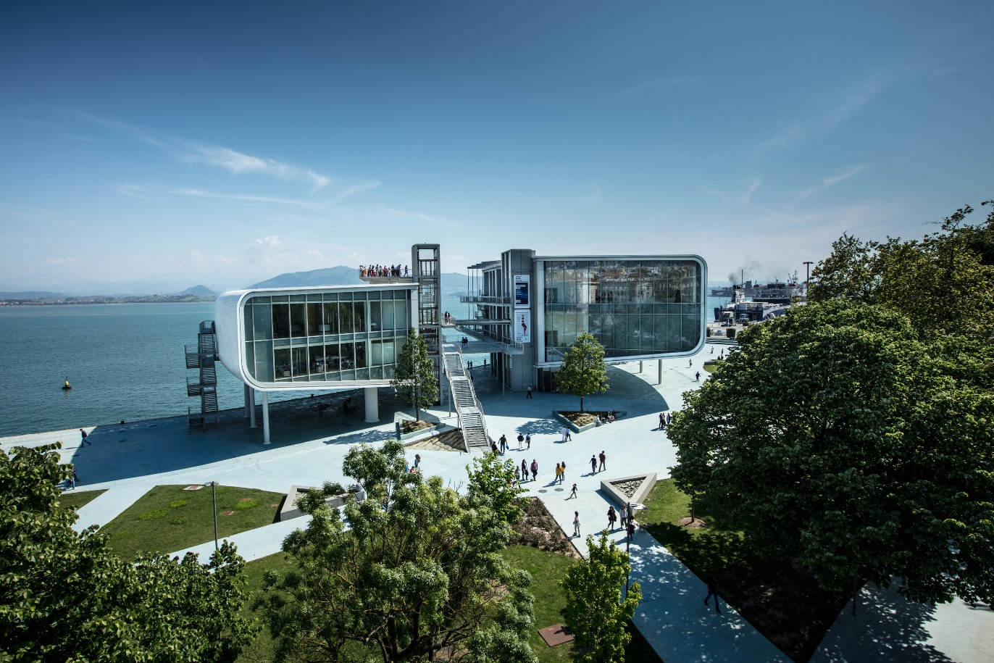

Ó Centro Botín. Enrico Cano

Centro Botín in Santander, Spain’s major new international centre for art, announces its exhibition programme for 2019.
Martin Creed and Anri Sala will each be the focus of a monographic exhibition - the first in Spain for Anri Sala. In addition, Centro Botín will present an innovative overview of the work of Alexander Calder. These exhibitions are announced alongside further showings from its permanent collection and a special exhibition marking the 25th anniversary of its programme of Visual Arts Grants.

ITINERARIOS XXV
16 February to 12 May 2019
Curator: Benjamin Weil, Artistic Director, Centro Botín
The Itinerarios exhibition cycle enables the annual presentation of the work produced by the eight recipients of the Fundación Botín Visual Arts Grant. 2019 will mark the 25thanniversary of Itinerarios: this new edition will present the work of eight artists, the 2017 recipients of the Fundación Botín Grant: Nora Aurrekoetxea (Spain), Fernando García (Spain), Cristina Garrido (Spain), Fermín Jiménez Landa (Spain), Rosell Meseguer (Spain), Shirin Sabahi (Iran), Blanca Ulloa (Spain), and Celia-Yuniorand Henry Eric Hernández (Cuba).

MARTIN CREED: AMIGOS
Visual Arts Workshop 25 March – 5 April 2019
Exhibition: 6 April to 9 June 2019
Curator: Benjamin Weil, Artistic Director of Centro Botín
Invited by Fundación Botín to run a Visual Arts Workshop in 2019, Martin Creed will collaborate with participating artists to create a new musical performance. This will be presented in the exhibition space for the duration of the workshop. The workshop’s completion will coincide with the launch of the new project, which includes the performance of a musical score composed during the workshop, and other contributions by the artist in the exhibition space, as well as all around it.
The work of visual artist and musician Martin Creed (Wakefield – United Kingdom, 1968) has been regularly presented around the world for nearly three decades. The artist, known for the range of his artistic output combining sculpture, painting, drawing, video and performance, was the 2001 winner of the Turner Prize, which he won with “Work No 227 – The lights going on and off.”

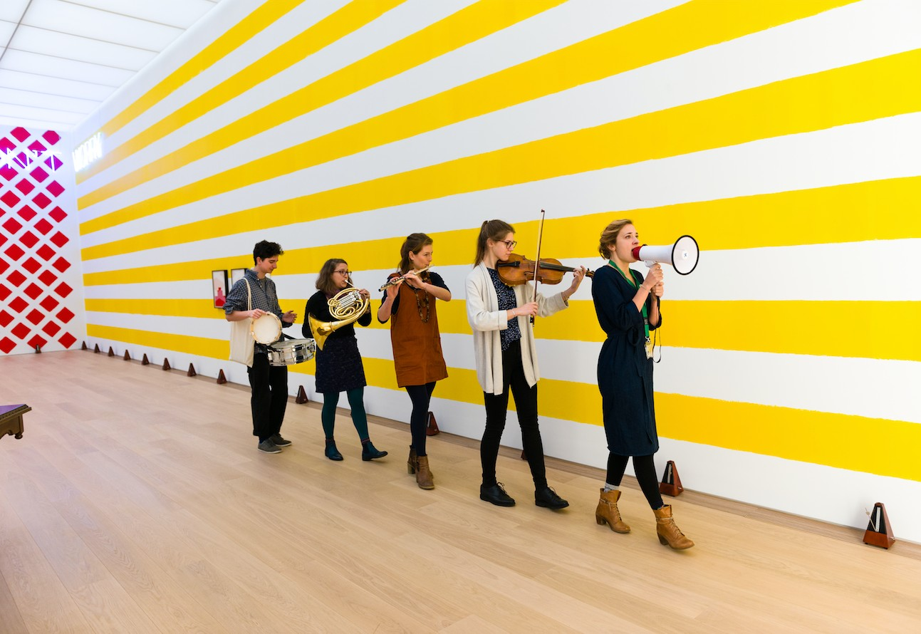

Martin Creed. Work No. 2734, 2016. Músicos itinerantes / Roving Musicians. Vista de instalación / Installation view, 'Martin Creed : SAY CHEESE!', Voorlinden Museum, Wassenaar, Paises Bajos / Netherlands, 20 enero /January - 11 Junio/ June 2017. © Martin Creed. DACS/VEGAP 2018. Photo: Antoine van Kaam.

EL GRITO SILENCIOSO. MILLARES SOBRE PAPEL
8 June to 15 September 2019
Curator: Maria Jose Salazar, member of the Visual Arts Advisory Committee at Fundación
Botín
Best known for his pictorial compositions using burlap, sacking, rope and other materials, Manolo Millares (La Palmas de Gran Canaria, 1921 – Madrid, 1972) is less known for his works on paper. Conceived exclusively for Centro Botín, and produced with the support and collaboration of the artist’s family, this exhibition is the first to be entirely dedicated to the artist’s drawings, many of which will be presented to the general public for the first time.

CALDER STORIES
29 June to 3 November 2019
Curator: Hans Ulrich Obrist, art critic and curator
Centro Botín will present a little-known aspect of the work of the illustrious American artist Alexander Calder (Lawton, Pennsylvania, 1898 – New York, 1976) - a series of drawings and models of unfulfilled projects by the artist from the early stages of his career until the final creations interrupted by his death. The exhibition, curated by Hans Ulrich Obrist, is produced in close collaboration with New York’s Calder Foundation.

Alexander Calder radically changed the course of modern art. He is known for the invention of the mobile, whose abstract suspended elements move and swing in a shifting
harmony. Expressed by Marcel Duchamp in 1931, the word “mobile” refers to both “movement” and “motive” in French. The first mobiles were powered by a system of engines, which Calder quickly gave up to focus instead on making sculptures whose elements moved with the force of airstreams and human interaction. Calder also created fixed abstract works, which were labeled “stabiles” by Jean Arp.

Starting in the 1950s, Calder concentrated on delivering monumental commissions, designed with sheets of steel for installation outdoors. His main sculptures included: 125, commissioned by the New York Port Authority for John F. Kennedy Airport (1957); Spiralefor UNESCO in Paris (1958); Teodelapio for the city of Spoleto, Italy (1962); Trois
Disques for Montreal’s Expo (1967); El Sol Rojo for the Olympic Games in Mexico (1968); La Grande Vitesse, the first public art work funded by the National Endowment for the Arts (NEA) for the city of Grand Rapids, Michigan (1969); and Flamingo for Chicago’s General Services Administration (1973).

Major retrospectives of Calder’s work during his lifetime took place at the George Walter Vincent Smith Gallery, in Springfield, Massachusetts (1938); at the Museum of Modern Art, New York (1943-44); at the Solomon R. Guggenheim Museum, New York (1964-65); at the Museum of Fine Arts, Houston (1964); at the Musée National d’Art Moderne, Paris (1965); at the Fondation Maeght, Saint-Paul-de-Vence, France (1969); and at the Whitney Museum of American Art, New York (1976-77). Calder died in New York in 1976 at the age of 78.
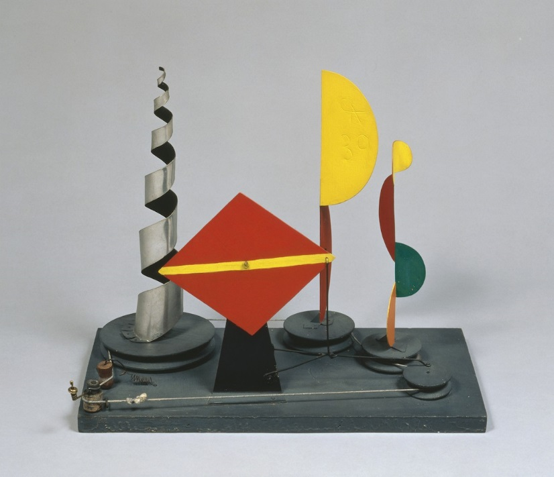

Untitled (maquette for 1939 New York World’s Fair), 1938.
© 2018 Calder Foundation, New York / Artists Rights Society (ARS), New York.
Courtesy of Calder Foundation, New York / Art Resource, New York.

ANRI SALA: ON THE GO (Chateaux en Espagne),
Exhibition: 14 December 2019 to 3 May 2020.
Curator: Benjamin Weil, Artistic Director, Centro Botin
A new exhibition by Anri Sala in Spain. Living between Paris and Berlin, the Albanian artist Anri Sala (Tirana – Albania, 1974) quickly made a name for himself on the international contemporary art scene through his audiovisual and audio installations. Moving images and music are at the core of his work; music is also the theme of a large part of his audio and video installations, as well as sculptures that often take the form of robotic musical instruments. The exhibition will present a new device for the display of moving images, enabling the creation of a meta-narrative in space from video works created by the artist in recent years.

THE FUNDACIÓN BOTÍN COLLECTION
25 Years of Itinerarios: Collecting practices
Exhibition: from 12 October 2019 until some time in 2020.
Curator: Benjamin Weil, Artistic Director of Centro Botín
To commemorate the 25 years of Itinerarios, a new display from the Fundación
Botín Collection will present new acquisitions as well as existing but rarely shown works in the collection. These include works by internationally acclaimed artists who ran visual arts workshops at Fundación Botín, as well as those of its former grant recipients. Some 200 works including paintings, sculptures, drawings, videos and multimedia installations by, among others, Leonor Antunes, Lothar Baumgarten, Carlo Bunga, Tacita Dean, Carlos Irrijalba, Joan Jonas, Julie Mehretu, Muntadas, João Onofre, Gabriel Orozco, and Sara Ramo. Also on show at Centro Botin

Until 3 March 2019 - CRISTINA IGLESIAS: ENTRƎSPACIOS
Curator: Vicente Todolí, Chairman of the Visual Arts Consultative Committee at Fundación
Botín.
Winner of the 1999 National Prize for Visual Arts, Cristina Iglesias (Saint-Sebastian, 1956) is one of the most important figures in Spanish contemporary art and enjoys an international reputation. This exhibition presents an important selection of the artist’s sculptures from the start of her career to the present and occupies the entire west wing of Centro Botín’s second floor. In addition to the temporary exhibition Iglesias is the creator of Desde lo subterráneo(From the underground), a monumental permanent installation located in the building’s surroundings, on the grounds of the Peredagardens.

Benjamin Weil, Artistic Director of Centro Botín, said: “We are happy and proud to offer visitors a new perspective on the work of Alexander Calder, thanks to the curation of Hans Ulrich Obrist. It is also a great honor to present the work of Anri Sala for the first time in Spain, as well as a new project by Martin Creed, two key artists on the contemporary scene. Each of these projects presents a unique perspective on the rich creative input of the arts today. With the exhibition of Manolo Millares’ drawings, the permanent gallery of great 20th-century portraits, and ItinerariosXXV, Centro Botín continues to present a wide range of artistic experiences, from the great masters of the last century to the promising talents of today.”

High-resolution images: https://www.dropbox.com/sh/meyay5r4mgfe05u/AAACVlb-PI0isGfvw1EnYY4Ua?dl=0

For press information:
Fundación Botín
María Cagigas mcagigas@fundacionbotin.org
Tel: (0034) 917 814 132

Claudine Collin Communication Thomas Lozinski Thomas@claudinecolin.com
Tel: +33(0) 1 42 72 60 01

For UK press inquiries:
Jane Quinn or Daisy Taylor, Bolton & Quinn jq@boltonquinn.com / daisy@boltonquinn.com Tel: 0207 221 5000

…………………………………………………………….

About Centro Botín
Centro Botín is a major new visual art centre in Santander, Spain, developed by Fundación Botín, a philanthropic Spanish institution founded in 1964.

The building, as well as the urban intervention within which it is located, linking the city centre and its bay, has been designed by the renowned architect Renzo Piano. As well as offering a new wide open door to art to the people of Santander city and the Cantabria region, it will strengthen the city’s social and cultural fabric and create a new attraction, in an exceptional seaside location, for all who visit Santander from around the world.

Led by an outstanding team of international experts, Centro Botín will, first and foremost, be dedicated to displaying and supporting art. It will also offer educational and wider cultural programmes, many of which will link the experience of art to the development of creativity and wellbeing.

The building will provide a home for the Fundación Botín’s permanent art collection, along with galleries for major exhibitions. Within the gallery spaces, and outside in the newly restored and extended Pereda Gardens, there will be displays of visual art of international calibre, from the historic to the contemporary. The building and its surrounds will also offer excellent and generous areas for performance, screenings, education, discussion and creative projects.

Centro Botín will provide a base from which the Fundación can build on its longstanding support for art and artists, through international exhibitions, workshops and scholarships, and also pursue research into drawing styles of the major Spanish artists of all periods.

Centro Botín will be a manifestation of the Fundación’s long held belief that seeing art has the power to awaken each individual’s creativity, and a key strand in the programming will be a pioneering research-led training programme to help people develop their emotional intelligence through art.

The mission of the Fundación Botín, from its inception in 1964, has been to contribute to society’s development. It does this by helping to generate cultural, social and economic wealth, not only in Cantabria, where it has always been based, but today also across Spain and as far afield as South America. The main focus is on uncovering and supporting creative talent in art, science, education and rural development. It is a potent mix of priorities, resulting in work that has enhanced the lives of many people, worldwide.

More information: www.centrobotin.org

