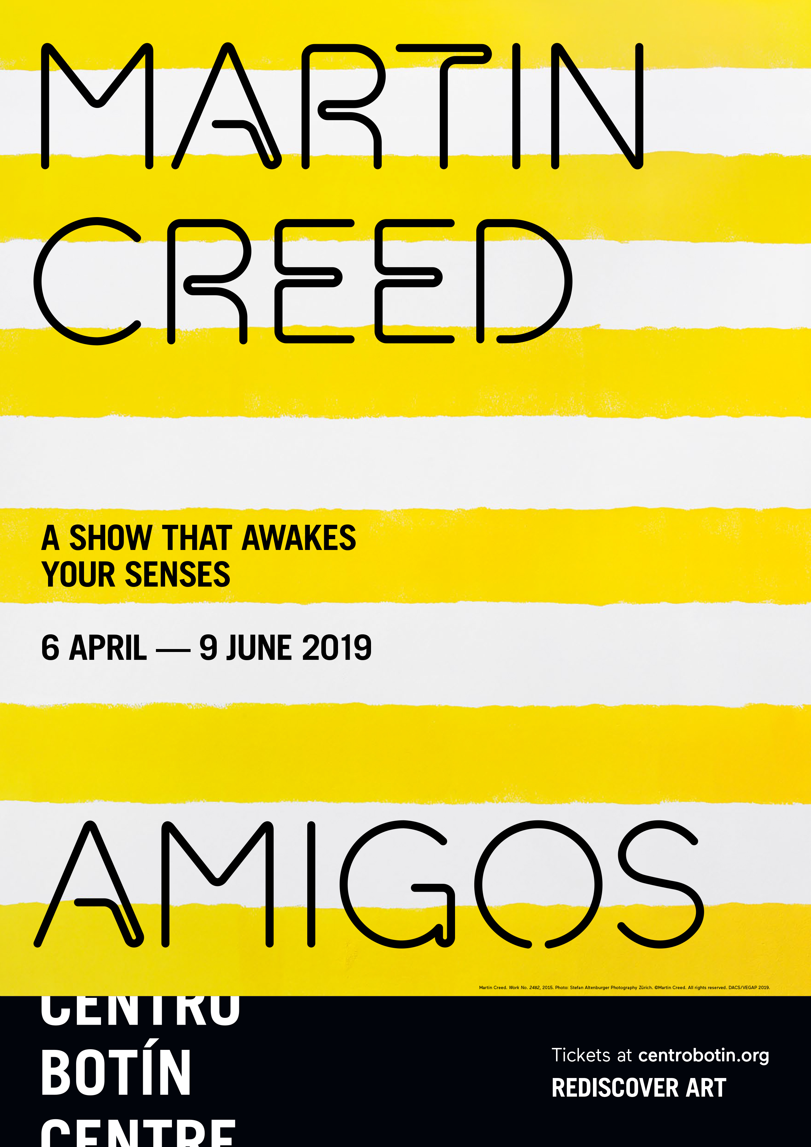
- MARTIN CREED UNFOLDS A MULTIDIMENSIONAL IMMERSIVE PROJECT IN THE CENTRO BOTÍN

- Curated by Benjamin Weil, artistic director of Centro Botín, the intervention “AMIGOS” will occupy a sequence of spaces in and around the building.
- A hybrid between exhibition and performance, the show will include over a dozen wall paintings, choreographed live music, recorded sound, and costumes.
- The British artist will direct a visual arts workshop from March 25 to April 5, during which he will create a new musical work, in collaboration with the participating artists, which will be performed during the entire course of the exhibition.
Santander, February 20, 2019 – As of April 6 and until June 9, 2019, Centro Botín presents a new, site-specific show by the British artist Martin Creed: “AMIGOS”. Curated by Benjamin Weil, artistic director of the Centro Botín, the project will begin at the end of the workshop the artist will direct from March 25 to April 5 at Fundación Botín. During the course of this workshop Creed will compose a new musical piece, which will subsequently be performed live in the exhibition space, among a series of wall paintings; the sound work will be played at all times during the opening hours of the museum and the entire course of the exhibition.
This pluridisciplinary and multi-dimensional project will unfold in the second floor galleries, but also the second-floor lobby; throughout the building, staff members will bear costumes altered by Creed. Visitors will also encounter a sound project in an elevator, as well as an artistic intervention in trees that surround the building. As often in his work, Creed invites the visitors to reconsider their environment, this time drawing their attention on gallery attendants, as well as on architectural elements one would usually tend to overlook. In doing so, he fosters a more acute and attentive look at the most menial aspects of the environment; a sense of awareness of the space and of the time spent in it. In that sense, he immerses the visitors in a different spatiotemporal dimension.
Martin Creed elaborates his projects taking into consideration the context and the space each will occupy. He composes his interventions with a number of elements, ranging from paintings and drawings to sculpture, sounds, moving image and live performance. In this instance, the choice of deploying a large number of Wall Paintings beyond the boundaries of the galleries transforms the perception of the space. The ongoing and roaming music performance creates a sense of pace, while the museum staff, akin to the performers, bears costumes as if to signify they are an integral part of the project. From the large bay windows of the museum, one observes the view, although altered by yet another element in the project. Creed once stated that he likes “to work without deciding in advance what I’m going to do. I find out as I go along whether it takes me to music, to painting or to something else. Each piece is an attempt at something, a little experiment. It’s a show of many experiments.”
The monumentality of the Wall Paintings contrasts with the relative bareness of the space, which calls for a different relationship to the exhibition, punctuated at each end by the monumental bay windows overlooking the Bay of Santander on one end and the City on the other. One’s visit is paced by the roaming musicians playing the quatuor imagined by the artist. The perception of time seems to shift, as one becomes more acutely aware with all senses awakened.
THE CREED PROPOSAL
Stretching from the surrounding Pereda gardens all the way into the Second-floor galleries, the project that Creed unfolds at Centro Botín occupies not only spaces usually dedicated to the exhibition of artworks, but also intermediary spaces where one rarely would stop or pay attention to. The roving musicians appear and disappear, in a choreography that may appear erratic, when it is in fact all carefully set by the artist. One could follow them or decide to await their return, wander around and enjoy the bright colors of monumental paintings that cover every single inch of white wall of the exhibition building’s second floor. Creed likes to use the word “show” to describe his work, as this refers not only to traditional exhibitions, but also to concerts or time-based performances.
Martin Creed prompt us to reflect on the notion of the exhibition as an experience in space and time as opposed to the contemplation of sets of fixed objects. Experimentation, doubt and sarcastic humour are fundamental aspects of a practice that sets out from the premise that all art comes from feeling. As he stated on previous occasions, “If I were forced to use a term for my work, I would call it expressionism because I believe that all artists express themselves in the things they do. The problem I have with conceptual art is that I don’t believe that it is possible to separate ideas from feelings.”
FORTHCOMING VISUAL ARTS WORKSHOP AT FUNDACIÓN BOTÍN
Since 1994, the Fundación Botín Visual Arts Workshops have brought together young artists from all over the world and such major creative talents as Tacita Dean, Carlos Garaicoa, Mona Hatoum, Carsten Höller, Cristina Iglesias, Joan Jonas, Jannis Kounellis, Julie Mehretu, Gabriel Orozco, Juliao Sarmento or Juan Uslé.
For his workshop, Martin Creed has invited artists interesting in music as well as musicians interested in art to a 10-day session during which they will work on scripting and composing a new sound work, while also working on their personal projects under his mentorship. The applicants are expected to master music theory, creative openness, as well as an ability to play with improvisation and a knowledge and experience of staging. The selected 15 also have the opportunity to remain in Santander for a longer period and participate in the performing of the score they will have composed with Creed.
BIOGRAPHICAL DATA
Martin Creed (Wakefield, United Kingdom, 1968), moved to Glasgow with his family when he was three years old, and has in fact always felt Scottish by adoption. From an early age he was in no doubt that art and music were his two great passions, and when he was 17 went to study at the Slade School of Art in London. Highly acclaimed as a visual artist and musician, Creed works in a wide range of media, including performance, installation, sound, text, sculpture, painting and drawing, among others.
Right from the start, with Work No. 3 (1986), Creed chose to number his works before adding titles, a nomenclature that adopts the system used to catalogue the work of the great classical composers, such as his Work No. 88: A sheet of A4 paper crumpled into a ball (1994) or Work No. 200: Half the air in a given space (1998), in which he famously filled half of the exhibition room with inflated balloons. The entire body of his work is like an archive: as a rule, his Works only take on material form when they are exhibited. The rest of the time they exist as a set of instructions to be meticulously executed each time they are put on show.
Martin Creed took the world of contemporary art by storm in 2001, when he was awarded the Turner Prize for his Work No. 227: The lights going on and off, a lighting installation that was subsequently acquired by the prestigious Tate Modern in London for its permanent collection.
The artist’s minimalist – and always controversial – approach has led him to dispense in his works with everything he considers out of place, unnecessary or irrelevant. Creed constantly shakes up currently accepted concepts of art, using commonplace materials and everyday situations in his pieces and bringing together art and daily life in a style of art-making that bewilders many and fills others with gleeful enthusiasm but leaves no one indifferent.
That Martin Creed was capable of enthusing people was made abundantly clear in 2012, with his officially commissioned work for the opening of the Olympic Games in London, when he managed to get thousands of women, men and children all over the United Kingdom (and even scientists at the British Antarctic research station) simultaneously ringing bells of all kinds (on front doors, on bicycles…), sounding car horns and even banging pots and pans as part of a gigantic performance he entitled Work Number 1119: All the bells in a country rung as quickly and as loudly as possible for three minutes. As he himself says: ‘Anything that people use as art is art.’
As for Creed’s musical work, his first band, Owada, was formed in 1994 with Adam McEwen and Keiko Owada, and in 2011 he set up his own label, Telephone Records. In addition to releasing a string of singles and albums, most recently in 2016, he has also composed orchestral works, including Work No. 955, for the Birmingham Symphony Orchestra; Work No. 994, for the Hiroshima Symphony Orchestra, and Work No. 1375, for the London Sinfonietta.

MARTIN CREED: AMIGOS
Dates: from April 6 to June 9, 2019
Curator: Benjamin Weil, artistic director of the Botín Centre.
Centro Botín
Muelle de Albareda, s/n
39004 Santander
For more information: www.centrobotin.org
Photographs for media use
Please register in the Press section of the Botín Centre website to download the available graphic material, both for the exhibition and for the building, and the corresponding credits.

………………………………………….
Botín Centre
  - The Botín Centre, designed by architect Renzo Piano, is a project of the Botín Foundation: a benchmark private art centre in Spain and on the international art circuit, in Santander the Botín Centre contributes at the highest level to the fostering of creativity and the generation of economic and social wealth by way of the arts. It is one of the world’s pioneering centres for the development of creativity, seeking to make the most of the potential of the arts to enhance our emotional intelligence and our creative capacities. It is also a place for people to meet on a privileged site in the city centre, and completes the cultural axis of the Cantabrian coast as a crucial factor in the national and international promotion of the city and the region. www.centrobotin.org

For more information:
Fundación Botín
María Cagigas
mcagigas@fundacionbotin.org
Tel.: 917 814 132

