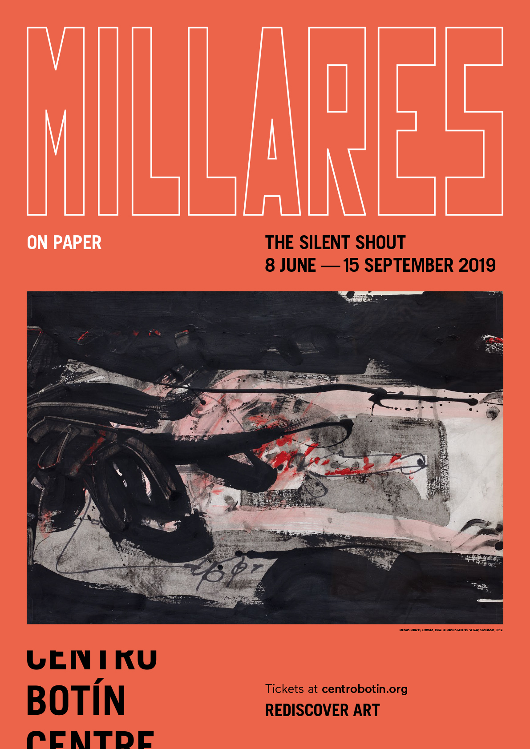
CENTRO BOTÍN PRESENTS THE SILENT SCREAM. MILLARES ON PAPER

• Conceived exclusively for Centro Botín, this is the first ever exhibition to be devoted entirely to a chronological presentation of the works on paper of Manolo Millares.
• The show, which will run from 8 June to 15 September, offers a comprehensive selection of 100 works spanning the full range and the different stages of the Canarian artist’s career, with particular emphasis on the period from 1955 to 1971.
• Put together with the active involvement and support of the artist’s family, and including a great number of previously unshown works, this ground-breaking exhibition is a timely reminder of Millares’s importance in the artistic and cultural milieus of his time.
Santander, 7 June 2019.- Centro Botín presents The Silent Scream. Millares on paper, the first exhibition devoted entirely to works on paper by Manolo Millares (Las Palmas de Gran Canaria, 1926 – Madrid, 1972). Conceived exclusively for Centro Botín, this exhibition invites the visitor to discover Millares’s work through four spaces, corresponding to the major chronological phases of the artist’s creative life, and to enjoy for the first time a large number of previously unshown works.
Curated by Maria José Salazar, a member of the Fundación Botín Visual Arts Advisory Committee, the exhibition is part of the ongoing body of research aimed at furthering out understanding and appreciation of drawing in Spanish art initiated by the Fundación Botín in 2006. Given that drawing is one of the most fascinating and fruitful facets of Spanish art from the sixteenth century to the present, the commitment of the Fundación Botín to this often undervalued medium is reflected in a pioneering series of new publications and a sequence of landmark single-artist shows devoted to the graphic work of the great Spanish masters, as in the case of the present Manolo Millares exhibition.
The exhibition, which can be visited at Centro Botín from 8 June to 15 September, has been put together with the active involvement and support of the artist’s family, and comprises a selection of 100 works covering the chronology of the successive stages of Millares’s creative output in terms of the new concept of drawing that came to the fore in the art world in those years of which he was a leading exponent. The show thus traces an arc from his somewhat academic beginnings in 1946, taking in some of his surrealist compositions and works with a Guanche influence and moving on through his pictographs to focus on the art he produced between 1955, when he moved to the Spanish mainland, and 1971, a few months before his untimely death: works of exceptional strength and personality, which led to his being recognized as one of the most important creative talents of his time.
Manolo Millares, one of the founders of the El Paso group in 1957, along with other major Spanish artists such as Antonio Saura, Manuel Rivera and Rafael Canogar, and celebrated for his use of burlap, sacking, rope and other unconventional materials, was brilliant and radically transgressive in his works on paper, as he was in all his artistic output. He was at the forefront of a conceptual change in drawing, then considered a minor discipline, in breaking with a method that, in Spain, had remained anchored in the canons of the nineteenth century. The Canarian artist incorporated the changes introduced by the international avant-gardes in his works on paper, in a way of working in which gesture, forcefulness and thought predominate and exalting new valued over established assumptions.
The whole body of Millares’s oeuvre is rooted in his environment and there is no doubt that he was a deeply committed artist in constant struggle with his historical, social and cultural moment. He belongs to that group of Spanish artists who, having emerged from a childhood marked by the war, formed in the dark nineteen fifties a movement through which to give voice, through their work, to the social situation of the country.
Four main stages can be identified in Millares’s work: an autodidactic first period of starting out and learning, and of naturalistic or realist academic drawing (1945 – 1948); an expressionist second phase of research and of searching (1948 – 1954); a third stage of consolidation and major innovation, in which the line has become a vital testimony (1955 – 1963); and a fourth period of plenitude, accusation and strength (1964 – 1971), in which his work came to full maturity and opened up a new path for drawing in this country.
Throughout the artist’s career there is a constant in his works on paper that clearly bears witness to his evolution: from figurative family portraits to compositions marked by a surrealist or constructivist influence and finally to loose sweeping gestures and broad strokes, in keeping with his painting, whether in graphite, in watercolour or in Indian ink.
With his drawings, Millares initiated a new form of expression, one that was no longer a lesser discipline subservient to the other arts: at that time, drawing was essentially used to render in a simple and spontaneous manner a mental process always ultimately oriented towards painting or sculpture, as a first support or preparatory sketch for a work in one of those artforms, and as such was considered a minor medium. Manolo Millares brought about a change that was not only conceptual but also external, in its visible form, in which the stroke and the gesture are given primacy over the line, which is spontaneous (except in the early works, prior to his move to the Spanish mainland in 1955), with a clear predominance of feeling over mere appearance.
Drawing was liberated, free to clear the way for works in which colour prevails and is even applied with gestural, expressionist brushwork. Objects or landscapes are represented, but without being enclosed in form, and resemblance or appearance is subordinate to poetry or musicality, to expression and communication. What matters, beyond representation, is the thought, the idea.
Jackson Pollock’s explorations of the potential of drawing, in the nineteen fifties, had a decisive influence on the form of expression and the system of work Millares developed in all his works on paper, creating a consistent and coherent ensemble that is part of the history of drawing in the twentieth century and, in the opinion of Maria José Salazar, the curator of the exhibition, also a revisiting of the past, and of the Far East, with works in which calligraphic script or poetry is combined with images, in Indian ink or wash.
These ‘paintings on paper’ are a constant throughout the artist’s career and clearly embody the new concept of drawing as evolving from academic forms in which the goal is realist resemblance to the subject to works in which the intellectual value is paramount and drawing is used to convey ideas and thoughts, in some cases as a means of communication and protest. There is in Millares’s art an evolution that goes in step with his life and times, making him the supreme exponent in this country of the changes that were taking place in the wider art world.
For all of these reasons, the works on paper presented in this exhibition are direct and compelling testimony to the ‘silent scream’ of the artist’s spirit as a dominant motive in his art. Millares was a creator who transcended and gave expression to his time and circumstances in the silent yet heartrending scream of his work.

THE SILENT SHOUT. MILLARES ON PAPER
Dates: from 8 June to 15 September, 2019
Curator: Maria José Salazar, a member of the Fundación Botín Visual Arts Advisory Committee.

Centro Botín
Muelle de Albareda, s/n
39004 Santander
For more information: www.centrobotin.org
Photographs for media use
Please register in the Press section of the Botín Centre website to download the available graphic material, both for the exhibition and for the building, and the corresponding credits.

………………………………………….
Botín Centre
  - The Botín Centre, designed by architect Renzo Piano, is a project of the Botín Foundation: a benchmark private art centre in Spain and on the international art circuit, in Santander the Botín Centre contributes at the highest level to the fostering of creativity and the generation of economic and social wealth by way of the arts. It is one of the world’s pioneering centres for the development of creativity, seeking to make the most of the potential of the arts to enhance our emotional intelligence and our creative capacities. It is also a place for people to meet on a privileged site in the city centre, and completes the cultural axis of the Cantabrian coast as a crucial factor in the national and international promotion of the city and the region. www.centrobotin.org

For more information:
Fundación Botín
María Cagigas
mcagigas@fundacionbotin.org
Tel.: (0034) 917 814 132

