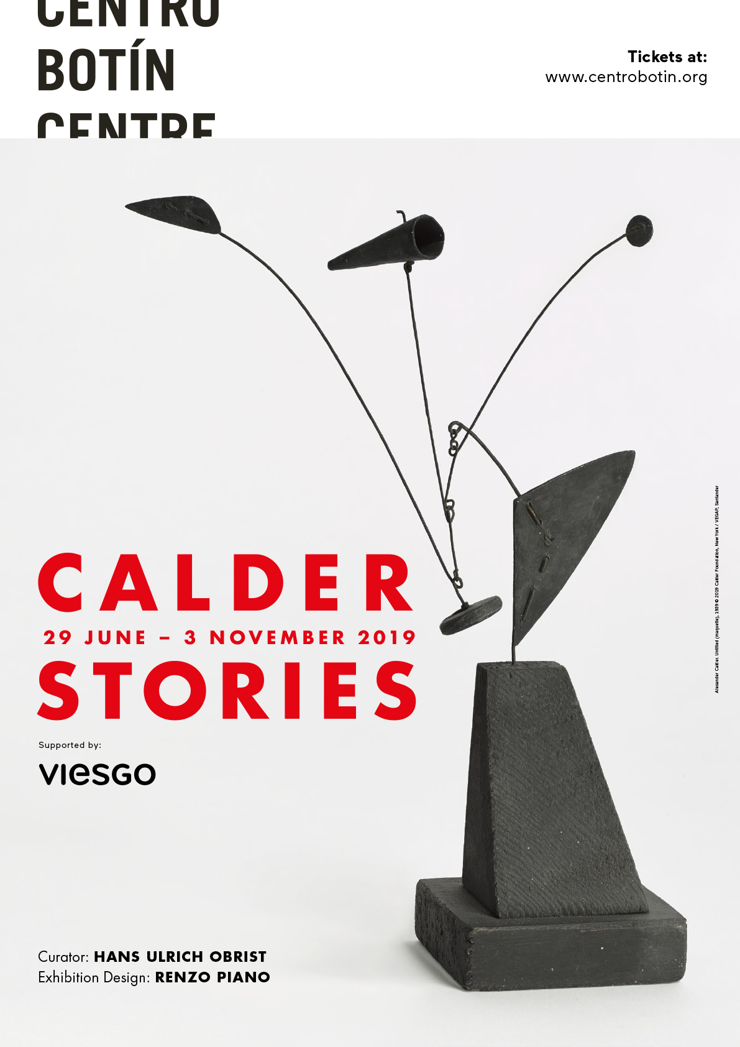
Press Release
MAJOR EXHIBITION ON ALEXANDER CALDER AT CENTRO BOTÍN IN SANTANDER

•CURATED BY HANS ULRICH OBRIST

•DESIGNED BY RENZO PIANO

Centro Botín in Santander, Spain, will present Calder Stories, a major exhibition spanning five decades of Alexander Calder’s career, curated by Hans Ulrich Obrist and organised in collaboration with the Calder Foundation, New York. The exhibition will run from 29 June – 3 November 2019. This exhibition is organized with the collaboration of VIESGO, a Spanish energy company.

The exhibition, comprised of approximately 80 works, largely drawn from the Calder Foundation’s holdings, as well as from major public and private collections, will consider little known stories within Calder’s oeuvre, from the development of major public commissions to groundbreaking performances. The installation will be designed by Pritzker Prize-winning architect Renzo Piano, architect of Centro Botín itself.

Calder’s collaborations with leading architects, choreographers and composers of his time resulted in some of his most recognised works, and yet their backstories remain largely unexamined. A number of these important projects went unrealised, including collaborations from the 1930 and 1940s with such luminaries as Wallace K. Harrison, Harrison Kerr and Percival Goodman. The exhibition traces Calder’s creative process in the execution of these projects, from his maquettes for sculpture competitions and world’s fairs to his proposals for choreographed objects and performances and including rare sketches and related ephemera.

Among the unrealised projects shown in the exhibition will be a series of six maquettes made by Calder in 1939 to accompany Percival Goodman’s submission for a proposed Smithsonian Gallery of Art in Washington; and a group of nearly two-dozen bronzes from 1944, made at the suggestion of Wallace K. Harrison for an International Style building and envisioned to stand some 10-12 metres tall in cast concrete. Drawings relating to what Calder termed ‘ballet objects’, including set designs for a proposed ballet with music by Harrison Kerr will be presented and digital animations of several compositions have been specially commissioned for the exhibition.

Hans Ulrich Obrist said: “Since 1990, I have gathered information on an unusual species of art: unrealised projects. These roads not taken are a reservoir of artistic ideas: forgotten projects, directly or indirectly censored projects, misunderstood projects, oppressed projects, lost projects, unrealisable projects. Whilst it is no longer possible to ask Calder about his unrealised projects, I thought that it would be interesting to apply this methodology of the unrealised to art history, and this exhibition at Centro Botín presents an exciting opportunity to do this for the first time”.

The exhibition will be accompanied by a fully illustrated catalogue with essays by Hans Ulrich Obrist, Alexander S. C. Rower, and Sandra Antelo-Suarez, among others.

Press Enquiries:
Jane Quinn or Daisy Taylor, Bolton & Quinn
E: jq@boltonquinn.com / daisy@boltonquinn.com
T: +44 20 7221 5000
M: +44 77 71858 728

To download high-resolution images:
https://bit.ly/2UDTVyx

Notes to Editors:

About Alexander Calder
Alexander Calder (Lawnton, PA, 1898 – New York, NY, 1976) utilized his innovative genius to profoundly change the course of modern art. Born into a family of celebrated, though more classically trained artists, Calder developed a new method of sculpting: by bending and twisting wire, he essentially "drew" three-dimensional figures in space. He is renowned for the invention of the mobile, whose suspended, abstract elements move and balance in changing harmony. Coined by Marcel Duchamp in 1931, the word mobile refers to both “motion” and “motive” in French. Some of the earliest mobiles moved by a system of motors, although these mechanics were virtually abandoned as Calder developed mobiles that responded to air currents, light, humidity, and human interaction. He also created stationary abstract works that Jean Arp dubbed stabiles.
From the 1950s onward, Calder turned his attention to international commissions and increasingly devoted himself to making outdoor sculpture on a grand scale from bolted steel plate. Some of these major commissions include: .125, for the New York Port Authority in John F. Kennedy Airport (1957); Spirale, for UNESCO in Paris (1958); Teodelapio, for the city of Spoleto, Italy (1962); Trois disques, for the Expo in Montreal (1967); El Sol Rojo, for the Olympic Games in Mexico City (1968); La Grande vitesse, which was the first public art work to be funded by the National Endowment for the Arts (NEA), for the city of Grand Rapids, Michigan (1969); and Flamingo, for the General Services Administration in Chicago (1973).
Major retrospectives of Calder's work during his lifetime were held at the George Walter Vincent Smith Gallery, Springfield, Massachusetts (1938); The Museum of Modern Art, New York (1943–44); Solomon R. Guggenheim Museum, New York (1964–65); The Museum of Fine Arts, Houston (1964); Musée National d'Art Moderne, Paris (1965); Fondation Maeght, Saint-Paul-de-Vence, France (1969); and the Whitney Museum of American Art, New York (1976–77). Calder died in New York in 1976 at the age of seventy-eight.
About Hans Ulrich Obrist
Since 1990, Hans Ulrich Obrist has initiated research on unrealized projects by contemporary artists, leading to the publication of Unbuilt Roads in 1997 (with Guy Tortosa) as well as of Dreams in 1999 (with Francesco Bonami – Fondazione Sandretto Re Rebaudengo, Turin). Obrist also co-founded the Agency for Unrealized Projects (AUP), a collaborative project with Serpentine Galleries and e-flux. Calder: Unrealized Projects will be the first time Obrist examines the work of a twentieth-century master through that prism.

About Renzo Piano
Renzo Piano was born in Genoa in 1937 into a family of builders. While studying at Politecnico of Milan University, he worked in the office of Franco Albini. In 1971, he set up the “Piano & Rogers” office in London together with Richard Rogers, with whom he won the competition for the Centre Pompidou. He subsequently moved to Paris. From the early 1970s to the 1990s, he worked with the engineer Peter Rice, sharing the Atelier Piano & Rice from 1977 to 1981. In 1981, the “Renzo Piano Building Workshop” was established, with 150 staff and offices in Paris, Genoa, and New York.

He has received numerous awards and recognitions among which: the Royal Gold Medal at the RIBA in London (1989), the Kyoto Prize in Kyoto, Japan (1990), the Goodwill Ambassador of UNESCO (1994), the Praemium Imperiale in Tokyo, Japan (1995), the Pritzker Architecture Prize at the White House in Washington (1998), the Leone d’oro alla Carriera in Venice (2000), the Gold Medal AIA in Washington (2008) and the Sonning Prize in Copenhagen (2009).

In 2004 he also founded the Renzo Piano Foundation, a non-profit organization dedicated to the promotion of the architectural profession through educational programs and educational activities. The new headquarters was established in Punta Nave (Genoa), in June 2008. In September 2013 Renzo Piano was appointed senator for life by the Italian President Giorgio Napolitano and in May 2014 he received the Columbia University Honorary Degree.

About Centro Botín
Designed by Pritzker Prize Winner architect Renzo Piano, Centro Botín was inaugurated in the summer of 2017, as the new home of Fundación Botín’s visual arts and public programs. Since its opening, Centro Botín has presented numerous monographic exhibitions which include: a rare display of Francisco de Goya’s drawings (in collaboration with Museo Nacional del Prado, Madrid); an exhaustive survey of sculptures by Joan Miró (co-curated by Joan Punyet, and in collaboration with Sucesió Miró); a new project by Carsten Höller; a survey of paintings and drawings by Julie Mehretu (co-produced with Museu Serralves, Porto); an exhibition of works by Cristina Iglesias. Initiated about three decades ago, the visual arts program of Fundación Botín is dedicated to: supporting young artists by way of grants and exhibitions, as well as workshops with more established peers; exhibiting works by key artists of our times; and showcasing lesser known aspects of the works of twentieth-century masters.

