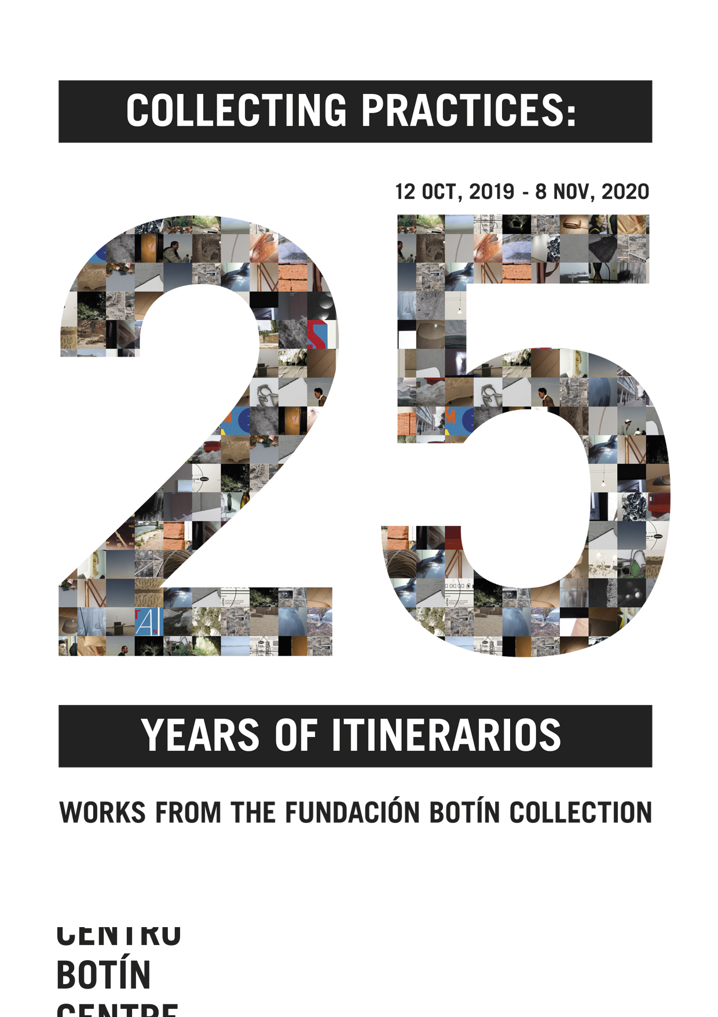
THE CENTRO BOTÍN PRESENTS
“COLLECTING PRACTICES. 25 YEARS OF ITINERARIOS”

- The exhibition will bring together a special selection of works by twenty-five outstanding artists, all of whom are former recipients of the Fundación Botín’s Visual Arts Grants, to celebrate the 25th anniversary of Itinerarios.
- The show will feature works by Basma Alsharif, David Bestué, Javier Arce, Bleda y Rosa, Patricia Esquivias, Adrià Julià, Leticia Ramos, Fernando Sánchez Castillo and Teresa Solar, among others.
- The exhibition will be open to the public in the first floor galleries of the Centro Botín from 12 October 2019 until 8 November 2020.
Santander, 11 October 2019. This year the Itinerarios series of annual exhibitions showcasing the work of the artists who have benefitted from one of the year’s Fundación Botín Visual Arts Grants celebrates its twenty-fifth anniversary, and to mark the occasion the Centro Botín is presenting Collecting Practices. 25 years of Itinerarios, a fascinating selection of works by twenty-five highly acclaimed artists who have received one of these Botín grants. The show will be open to the public from tomorrow, 12 October 2019, until 8 November 2020.

‘This exhibition is testimony to the Fundación Botín’s ongoing commitment to supporting the most contemporary art practice, and bears eloquent witness to how this practice has evolved since the end of the last century,’ writes Benjamin Weil, artistic director of the Centro and curator of the show. Characterized by its considerable formal versatility, the exhibition presents works in a wide range of formats and media, from sculpture and installation to photography and video, as well as various combinations thereof. The common ground is a strong sense of narrative: the process of art-making remains consciously visible in many of these works. More than ever, the artwork itself is the presentation of a process of creative thinking framed in time – a snapshot of sorts.
Many of the chosen works are from an early stage in the artist’s career, so that part of their interest resides in the way they often prefigure research processes which are still acutely relevant today. At the same time the exhibition reveals the extent to which, over the years, artists have adopted cutting-edge technologies as a new craft practice, augmenting digital images with some handmade element, be it drawing or sculpture, to create scenarios that also use the exhibition space as a stage. ‘They invite us as visitors to engage with them as the authors of our own experience: their works are surfaces of interpretation, remaining open, to be completed by each visitor’s own understanding,’ Weil notes.
The exhibition will feature the work of 26 artists: Lara Almarcegui (1972), with her Descampados de Ámsterdam, 1998 – 1999; Basma Alsharif (Kuwait, 1983), with Cornices of Beirut, from 2010; Leonor Antunes (Portugal, 1972), with Random Intersection #14, 2017; Javier Arce (1973), with his series Struth, 2007; Erick Beltrán (Mexico, 1974), with Multiplicidad del mundo, 2010; David Bestué (1980), with Elementos del pasado. Dos luces, 2015, and Elementos del pasado. Trencadissa, 2013; María Bleda (1969) and José María Rosa (1970), with four works from his series Origen: Cráneo de Gibraltar. Forbes Quarry, 2003, Homo Spyensis. Spy, 2007, Homo Floresiensis. Liang Bua, 2007, and Hombre de Pacitan. Song Terus, 2007; Nuno Cera (Portugal, 1972), with Symphony of the Unknown, 2012 – 2013; Patricia Dauder (1973), with Les Maliens (a film), 2007; Patricia Esquivias (Venezuela, 1979), with Walking Still, 2014; Karlos Gil (1984), with L´histoire de la Ergonomie, 2016; Carlos Irijalba (1979), with Inercia, 2012; Adrià Julià (1974), with Ejercicio para un paisaje sobreexpuesto (#1), 2017; Juan López (1979), with Locals Only, 2019; Rogelio López Cuenca (1959), with Life, 1988, and Lauha (painting), 2000; Renata Lucas (Brazil, 1971), with MHC Case, 2014; Mateo Maté (1964), with Desubicado, 2003; Jorge Méndez Blake (Mexico, 1974), with Du fond d'un naufrage, 2011; Regina de Miguel (1977), with Isla Decepción, 2017; Leticia Ramos (Brazil, 1976), with Universal History of Earthquakes, 2017; Fernando Sánchez Castillo (1970), with Born Again, 1999; Teresa Solar Abboud (1985), with Al Haggara, 2015 and Palio de noche, 2015; Leonor Serrano Rivas (1986), with The Dream Follows the Mouth (of the one who interprets it), 2018; and Jorge Yeregui (1975), with Atajos, 2015; and David Zink-Yi (Peru, 1973), with Untitled, 2013.
The commitment of the Fundación Botín
The Fundación Botín centres its commitment to the visual arts on the process of artistic creation and the exchange of knowledge, and does so by means of a pair of initiatives that underpin both its exhibition programme and its collection: the Visual Arts Grants and the Visual Arts Workshops.
The programme of Visual Arts Grants, initiated in 1993, with the next iteration due to start in February 2020, was set up to support young artists in creating and making known their most ambitious projects, in which they combine research and production, while at the same time giving them the opportunity to complete and extend their training. In step with this, the first of the Visual Arts Workshops was held in 1994, and every year since then they have brought together an artist-mentor of international standing and a group of fifteen young artists, in an enriching in-depth ten-day residential encounter.
In addition to shaping the Fundación Botín collection and its programme of exhibitions, the grants and workshops have the additional virtue of fostering a better understanding and a fuller appreciation of contemporary art on the part of the wider public. To this end the Fundación Botín Collection, which continues to grow year on year, brings together works by the mentors of the Visual Arts Workshops, consolidated international artists, who live with the works of the creators who have enjoyed one of the foundation’s Visual Arts Grants. All together they make up a plural mosaic of concepts and trajectories that, in their generational difference and positions, together represent a fantastic testimony of the art of our day.
The Itinerarios collective
In 1994 the Fundación Botín held the first of the series of Itinerarios exhibitions, which mark the culmination of each year’s Visual Arts Grants and at the same time further support the artists by providing a platform for the works created during the period of the grant. Initially the foundation also invited them to donate a piece to its collection, as well as acquiring over the years new works by former grantees to complement the earlier pieces and provide a deeper understanding of these artists’ visual researches. As of 2014, all new acquisitions have been by purchase.
To date, Fundación Botín Visual Arts Grants have been awarded to 210 artists, the majority of whom are still active and enjoying successful careers. For all of the above reasons, Collecting Practices. 25 years of Itinerarios offers an illuminating perspective on the evolution of this series of exhibitions and on the distinctive approach of the foundation to the process of building up its collection.
COLLECTING PRACTICES. 25 YEARS OF ITINERARIOS
Dates: from 12 October 2019 until 8 November 2020
Curator: Benjamin Weil, artistic director of the Centro Botín.
Centro Botín
Muelle de Albareda
39004 Santander
For more information: www.centrobotin.org
Photographs for the use of the media
You can register in the Press section of the Centro Botín website to download the available visual materials relating to both the exhibition and the building, together with the corresponding credits.

………………………………………….
Centro Botín
The Centro Botín, designed by the architect Renzo Piano, is a project of the Fundación Botín. One of Spain’s outstanding private art centres and a key element on the international art circuit at the highest level, which contributes by way of the arts to the generation of economic and social wealth in Santander. It is also a world-class pioneer in the development of creativity, in making full use of the potential of the arts in the fostering of our emotional intelligence and the creative capacity. In addition, the Centro Botín is a place of encounter, a privileged enclave in the heart of the city and the new cornerstone of the cultural arc of the Cantabrian coast – an engine of the national and international promotion of the city and the region. www.centrobotin.org.

For more information:
Fundación Botín
María Cagigas
mcagigas@fundacionbotin.org
Tel.: (0034) 917 814 132

